Task No. 02: Output of examples mentioned in the Lab.

Example No 01:
Solution:
using System;

namespace Abdullah_Sadiq
{
class Program
{
static void Main(string[] args)
{
Console.WriteLine("Hello World!");
}
}
}
Output:
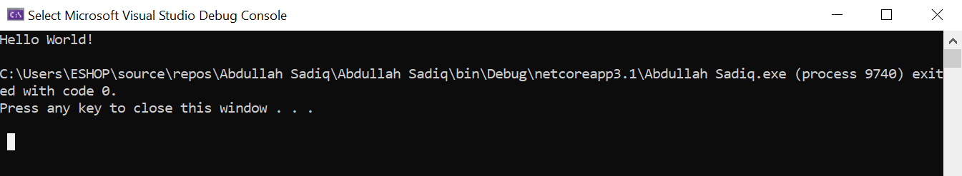
Example No 02:
Input:
using System;

namespace Example_no_02
{
class Program
{
static void Main(string[] args)
{
Console.WriteLine("Abdullah Sadiq");
Console.WriteLine("Age = 17");

Console.Write("Hobby = Photography ");
Console.Write("(Because I like it)");
}
}
}
Output: 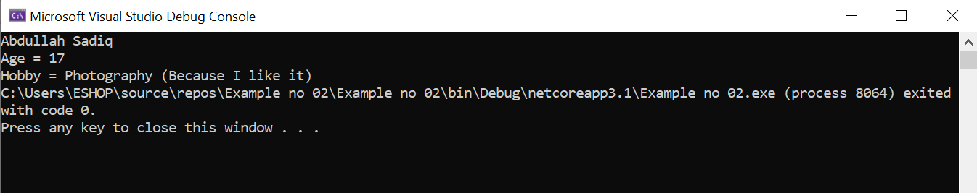
4

